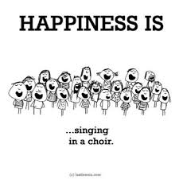
Dear Parents,

Sly Sound is an elite, auditioned group of singers who will perform high-level children’s music at school and throughout the community. This group is open by audition to all 4th and 5th grade students.
Auditions will be held in September, and will consist of familiar tunes and matching pitches- nothing to be worried about!
Rehearsals will be held in the MORNING from 7:45-8:45am. This year, ALL 4th and 5th grade students will meet on THURSDAY MORNINGS. The audition date for all new members is Thursday, September 21st from 8am-8:45am.
The absolute, no excuses deadline for this form to be returned (and to be eligible to audition) is MONDAY, SEPTEMBER 18TH.

My child ____________________________________________ has permission to audition for Sly Sound

Contact Number______________________________ Teacher Name ____________________________

Parent Email _________________________________________________________________________

Parent Signature ______________________________________________________________________
If you have any questions or concerns, please contact me at ehartley@wcpss.net
Thanks,
Elizabeth Hartley
Music Specialist, Forest Pines Drive Elementary

